 | Phone: | 01772 537960
 | Email: | roadsafetyeducation@lancashire.gov.uk

ROAD SAFETY TEAM REQUEST - PLEASE DISPLAY YOUR BANNER IN A SAFE PLACE

Dear Headteacher

Thank you for working with us to promote Road Safety and reduce parking congestion at your school. You may wish to develop banners to be displayed outside school as these can be an excellent way to communicate messages.
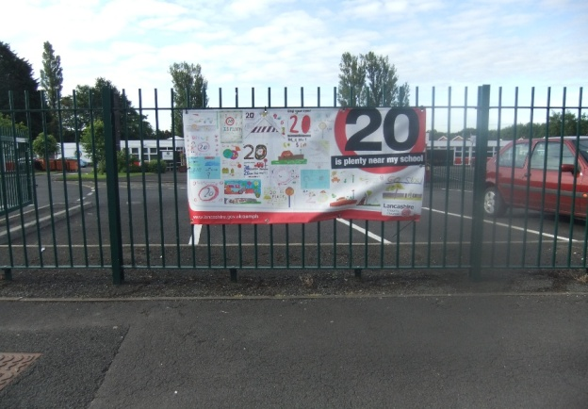
Please bear in mind when positioning banners that they must be displayed to the rear of the footway, for example on school railings, and not obstructing sight lines to gates or other exits\entrances. They should not under any circumstances be sited on safety barriers between the footpath and the highway. Covering or obstructing a safety barrier interferes with the sightline between drivers and pedestrians, particularly small children who may be walking unseen behind the barrier and suddenly emerge onto the road.
Picture above shows correct positioning of banner

Please continue the excellent work you and your children have done and remember to display your banner in a safe place.

Yours Sincerely

Road Safety Team
(Education and Engagement)

roadsafetyeducation@lancashire.gov.uk

